3

Analyses of Beams and Frames

Exercise 1

* Create the beam’s skeletal model

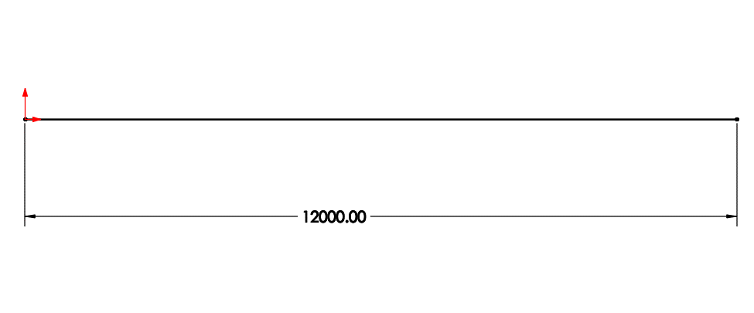

* Generate the weldment profile

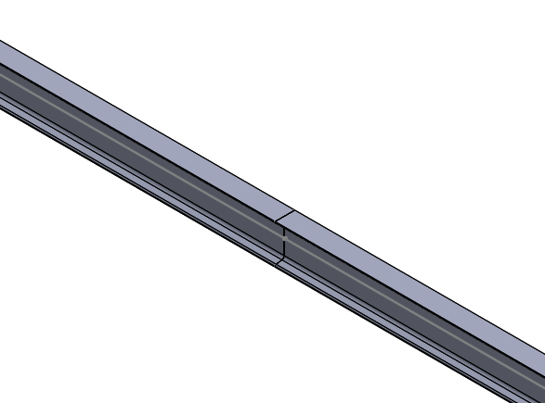

* Complete the solution study
  + Apply boundary conditions/fixture
  + Apply force

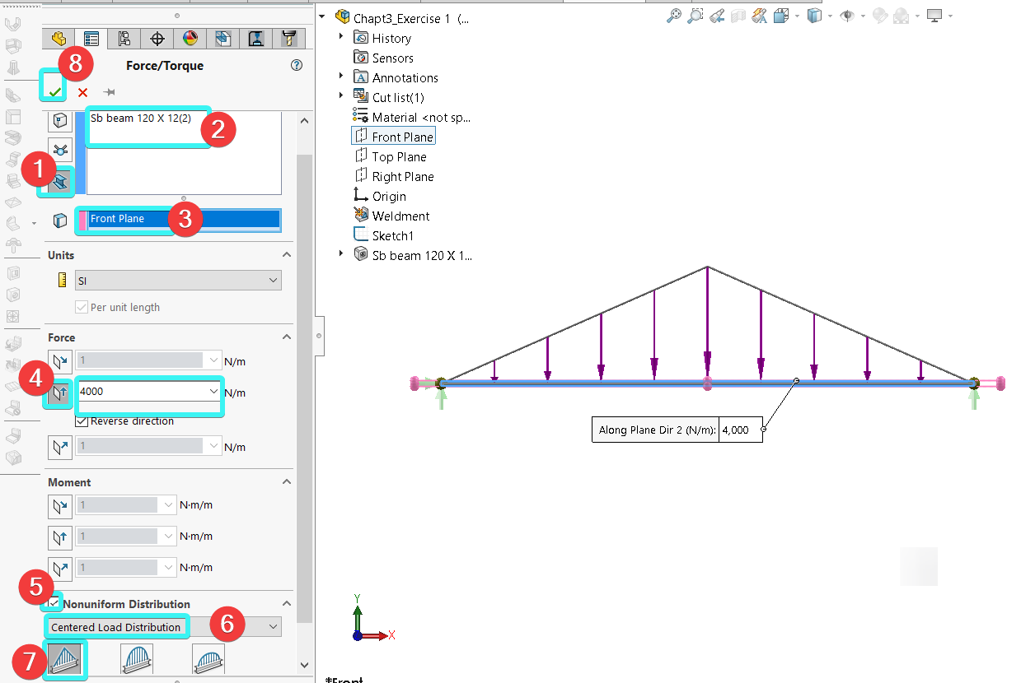

* + Get the solutions/results

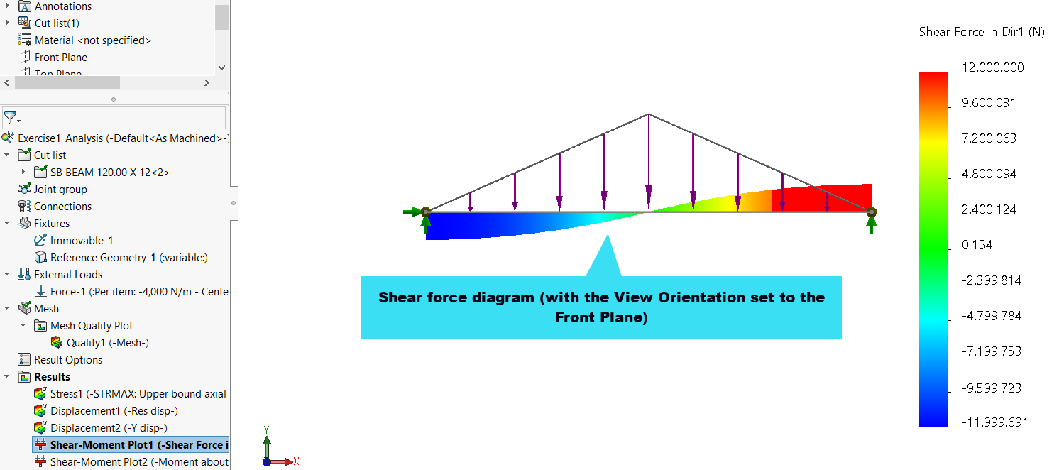

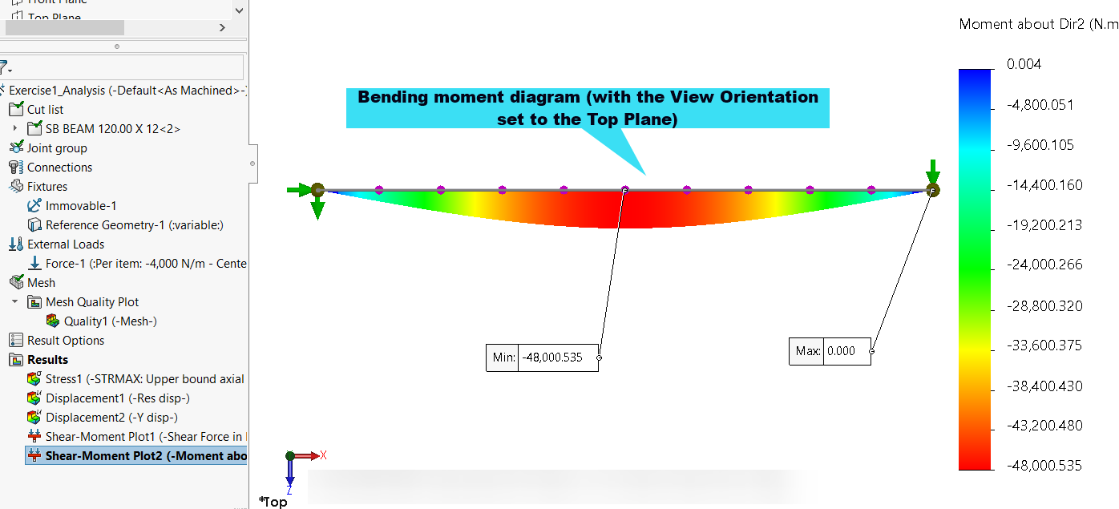

Note, when you open the SOLIDWORKS file, you may notice that the results are greyed out. Re-run the analysis as indicated below to re-compile the results.

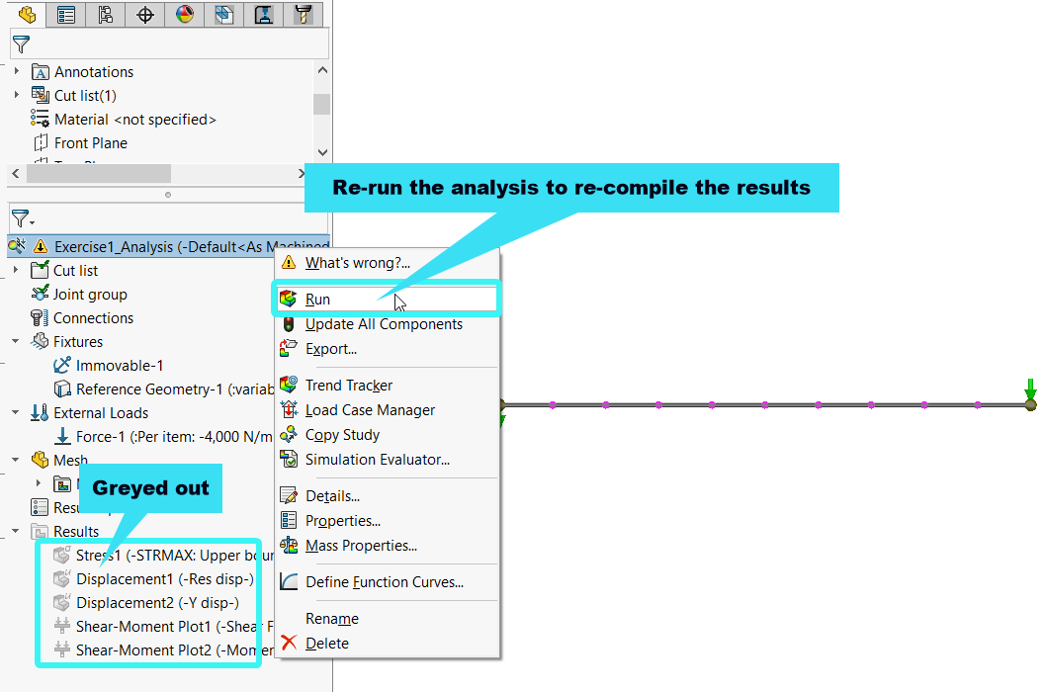

Exercise 2

* Create the bicycle frame’s skeletal model

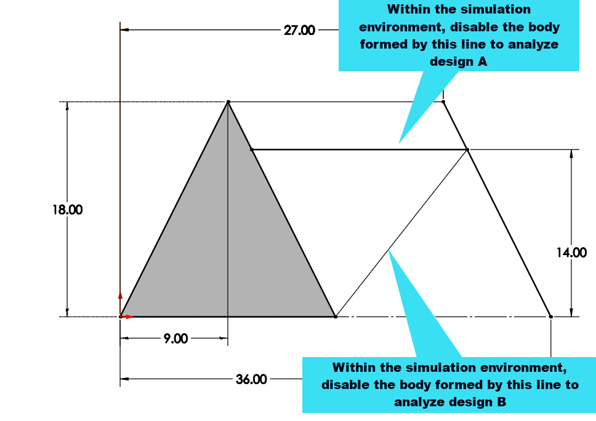

* Generate the weldment profile

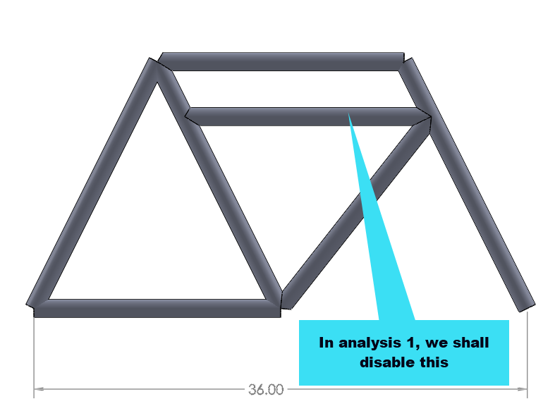

**Design A:**

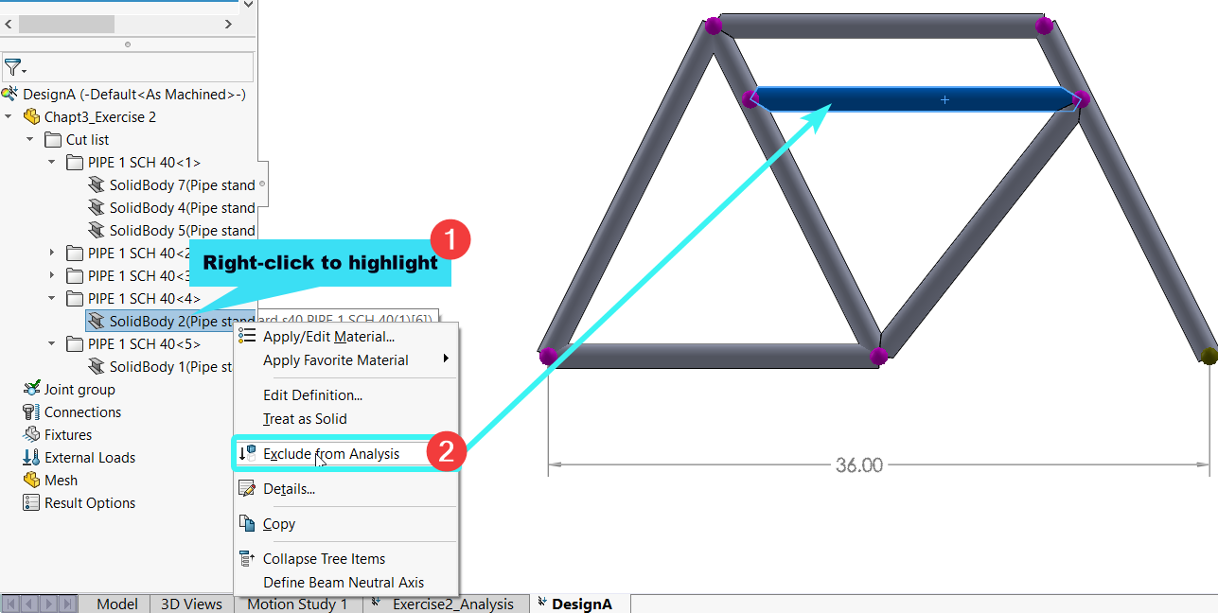

**Design B**

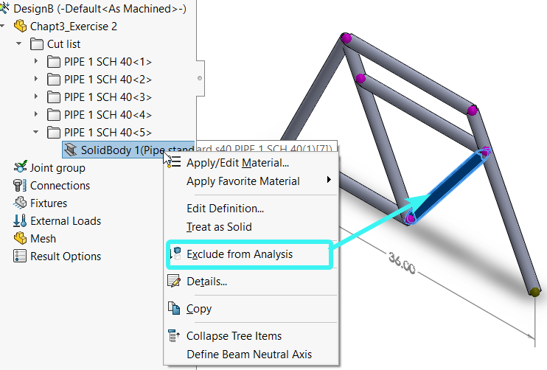

* Create the simulation set-up
  + Apply material, fixture, and loads
    - Apply at C and at E
    - *Assume fixed support at point A, then roller support at point H*
      * **Design A**

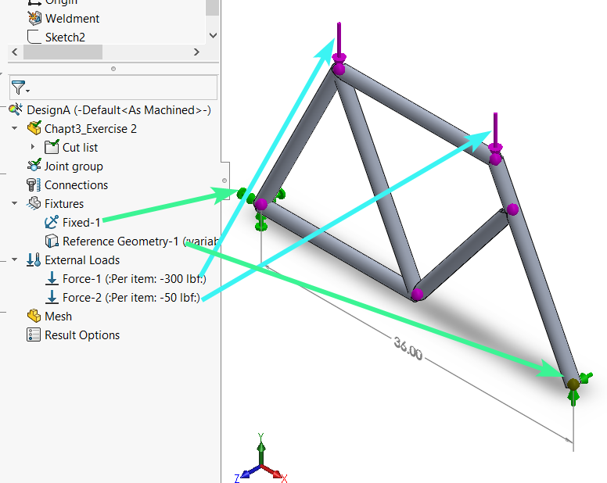

* + - * **Design B**

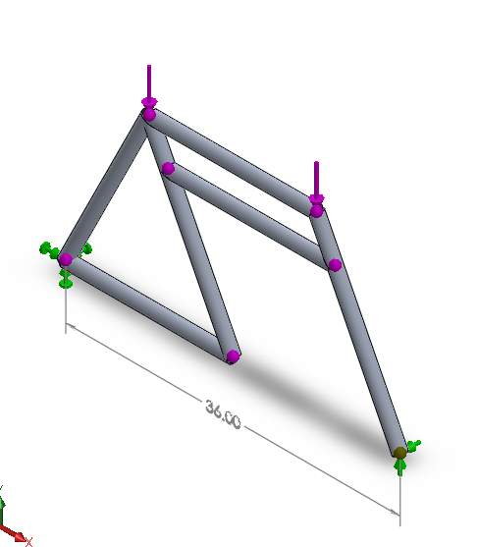

* Complete the solution
  + **Design A**
    - Maximum deflection along the Y-axis

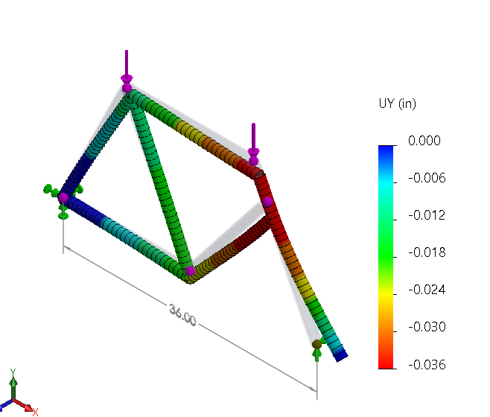

* + - Maximum bending stress along direction 2

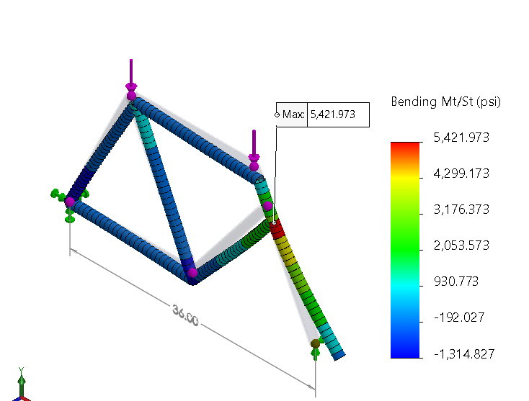

* + **Design B**
    - Maximum deflection along the Y-axis

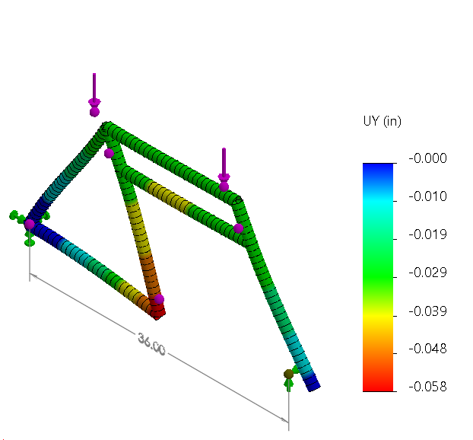

* + - Maximum bending stress along the direction 2

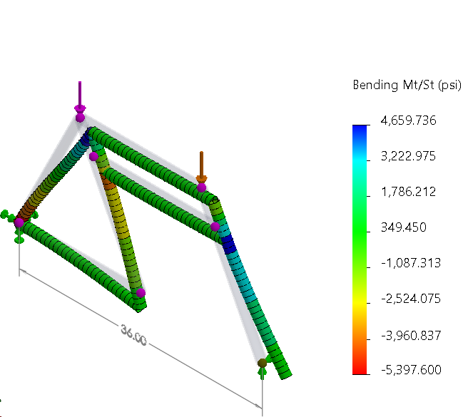

Exercise 3

* Create the frame’s skeletal model

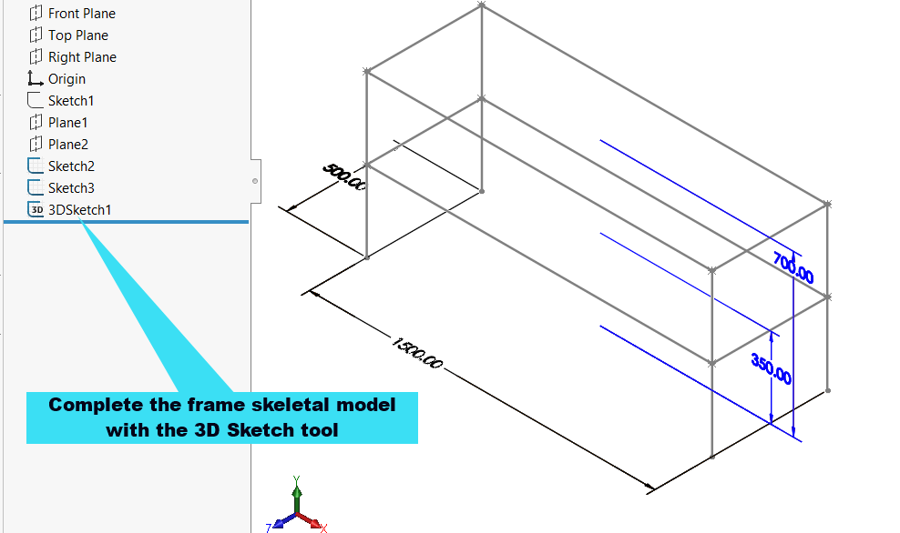

* Generate the weldment profile of the frame

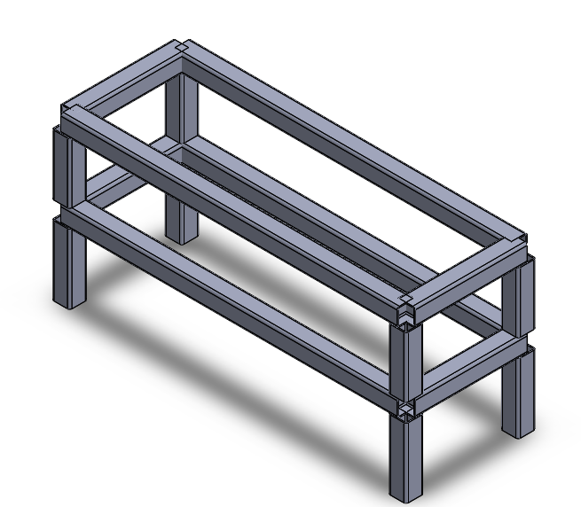

* Create the simulation set-up
  + Apply material, fixture, and loads
    - Apply 8000 N/m on each of the beams
    - *Assume fixed support for the four points at the base of the frame*

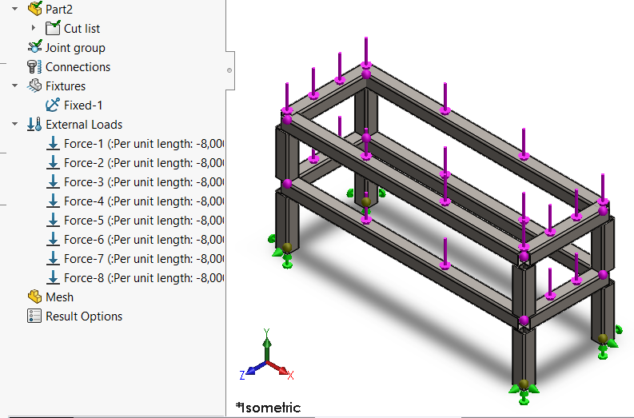

* Complete the solution
  + Maximum deflection along Y

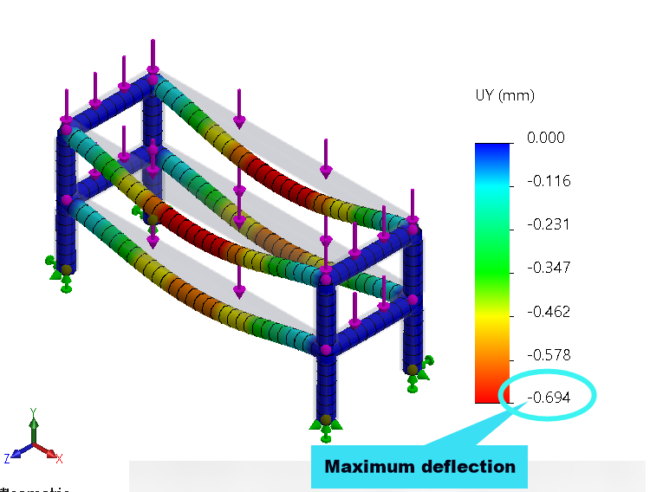

* + Maximum bending stress along direction 1

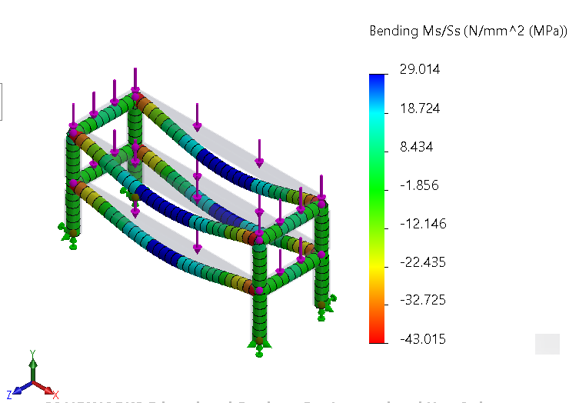

* + Maximum bending stress along direction 2

